# PIZZA SALES SQL QUERIES

**A.KPI’S**

**1.Total Revenue:**

SELECT SUM (total_price) AS Total_Revenue FROM pizza_sales;

**2.Average Order Value:**

SELECT SUM (total_price)/COUNT (DISTINCT order_id) AS Avg_Order_Value FROM pizza_sales;

**3.Total Pizzas Sold:**

SELECT SUM (quantity) AS Total_Pizza_Sold FROM pizza_sales ;

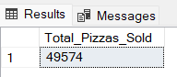

**4.Total Orders:**

SELECT COUNT (DISTINCT Order_id) AS Total_Orders FROM pizza_sales ;

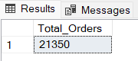

**5.Average Pizzas per Order:**

SELECT CAST (SUM (quantity) AS DECIMAL (10,2))/CAST (COUNT (DISTINCT Order_id) AS DECIMAL (10,2)) AS Avg_Pizzas_Per_Order FROM pizza_sales ;

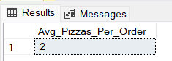

**B. Daily Trend for Total Orders:**

SELECT DATENAME (DW, order_date) AS order_day, COUNT (DISTINCT order_id) AS Toatl_orders FROM pizza_sales GROUP BY DATENAME (DW, order_date)

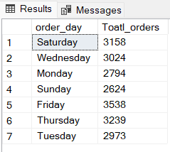

**C. Monthly Trend for total Orders:**

SELECT DATENAME (MONTH, order_date) AS MONTH_Name, COUNT (DISTINCT order_id) AS Total_Orders FROM pizza_sales GROUP BY DATENAME (MONTH, order_date)

**D. Percentage of sales by Pizza Category:**

SELECT pizza_category, CAST (SUM (total_price) AS DECIMAL (10,2)) AS total_revenue,

CAST (SUM (total_price) * 100 / (SELECT SUM (total_price) FROM pizza_sales) AS DECIMAL (10,2)) AS PCT

FROM pizza_sales

GROUP BY pizza_category

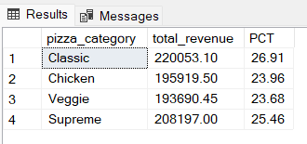

**E.% Of Sales by Pizza Size:**

SELECT pizza_size, CAST (SUM (total_price) AS DECIMAL (10,2)) AS total_revenue,

CAST (SUM (total_price) * 100 / (SELECT SUM (total_price) FROM pizza_sales) AS DECIMAL (10,2)) AS PCT

FROM pizza_sales

GROUP BY pizza_size

ORDER BY pizza_size

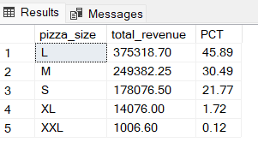

**F. Total Pizzas Sold by Pizza Category**

SELECT pizza_category, SUM (quantity) AS Total_Quantity_Sold

FROM pizza_sales

WHERE MONTH (order_date) = 2

GROUP BY pizza_category

ORDER BY Total_Quantity_Sold DESC

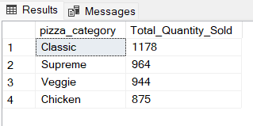

**G. Top 5 Pizzas by Revenue:**

SELECT Top 5 pizza_name, SUM (total_price) AS Total_Revenue

FROM pizza_sales

GROUP BY pizza_name

ORDER BY Total_Revenue DESC

H. **Bottom 5 Pizzas by Revenue**

SELECT Top 5 pizza_name, SUM (total_price) AS Total_Revenue

FROM pizza_sales

GROUP BY pizza_name

ORDER BY Total_Revenue ASC

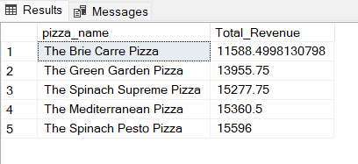

**I. Top 5 Pizzas by Quantity**

SELECT Top 5 pizza_name, SUM (quantity) AS Total_Pizza_Sold

FROM pizza_sales

GROUP BY pizza_name

ORDER BY Total_Pizza_Sold DESC

**J. Bottom 5 Pizzas by Quantity**

SELECT TOP 5 pizza_name, SUM(quantity) AS Total_Pizza_Sold

FROM pizza_sales

GROUP BY pizza_name

ORDER BY Total_Pizza_Sold ASC

**K. Top 5 Pizzas by Total Orders**

SELECT Top 5 pizza_name, COUNT (DISTINCT order_id) AS Total_Orders

FROM pizza_sales

GROUP BY pizza_name

ORDER BY Total_Orders DESC

**L. Bottom 5 Pizzas by Total Orders**

SELECT Top 5 pizza_name, COUNT(DISTINCT order_id) AS Total_Orders

FROM pizza_sales

GROUP BY pizza_name

ORDER BY Total_Orders ASC

